Ex.no:4
Date:4/4/25
5. Create web form that accepts a user’s name and age.Write a servlet to process the form data and display it back on the browser.
Aim:
Create web form that accepts a user’s name and age.Write a servlet to process the form data and display it back on the browser.

Program:
User.html:
<!DOCTYPE html>
<html>
<head>
<meta charset="ISO-8859-1">
<title>Insert title here</title>
</head>
<body>
<form
action="http://localhost:7750/Dynamic_web_project_shruthi/DisplayUser">
<label for="name">Name:</label> <input type="text"
id="first name" required placeholder="hi user" name="name"> <br>
<p>
<label for="age">Age:</label> <input type="text"
name="age" id="age" required>
</p>
<br> <input type="submit" value="ACCEPT">
</form>

</body>
</html>
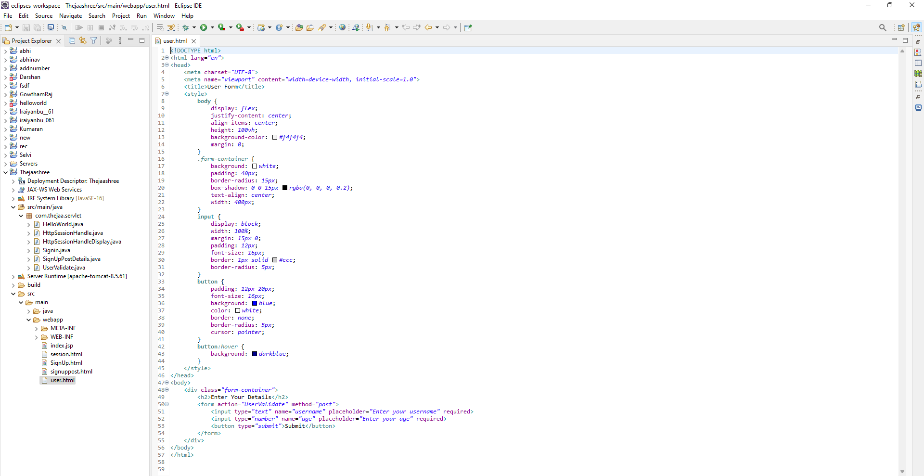

DisplayUser.java:
package com.thejaa.servlet;

import java.io.IOException;
import java.io.PrintWriter;

import javax.servlet.ServletException;
import javax.servlet.annotation.WebServlet;
import javax.servlet.http.HttpServlet;
import javax.servlet.http.HttpServletRequest;
import javax.servlet.http.HttpServletResponse;

/**
* Servlet implementation class DisplayUser
*/
@WebServlet("/DisplayUser")
public class DisplayUser extends HttpServlet {
private static final long serialVersionUID = 1L;

/**
* @see HttpServlet#HttpServlet()
*/
public DisplayUser() {
super();
// TODO Auto-generated constructor stub
}

/**
* @see HttpServlet#doGet(HttpServletRequest request, HttpServletResponse response)
*/
protected void doGet(HttpServletRequest request, HttpServletResponse response) throws ServletException, IOException {
String a=request.getParameter("name");
int b = Integer.parseInt(request.getParameter("age"));
PrintWriter p=response.getWriter();
if (b > 0 && a!=null) {

p.println(a);
p.println(b);
}
else {
p.println("Enter valid age");
}

}

/**
* @see HttpServlet#doPost(HttpServletRequest request, HttpServletResponse response)
*/
protected void doPost(HttpServletRequest request, HttpServletResponse response) throws ServletException, IOException {
// TODO Auto-generated method stub
doGet(request, response);
}

}

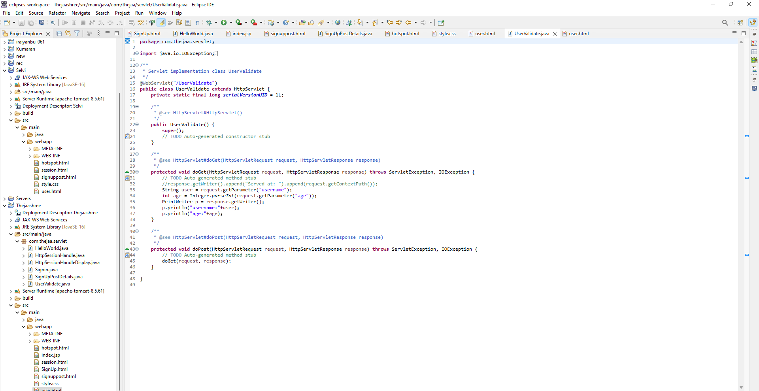

Output:

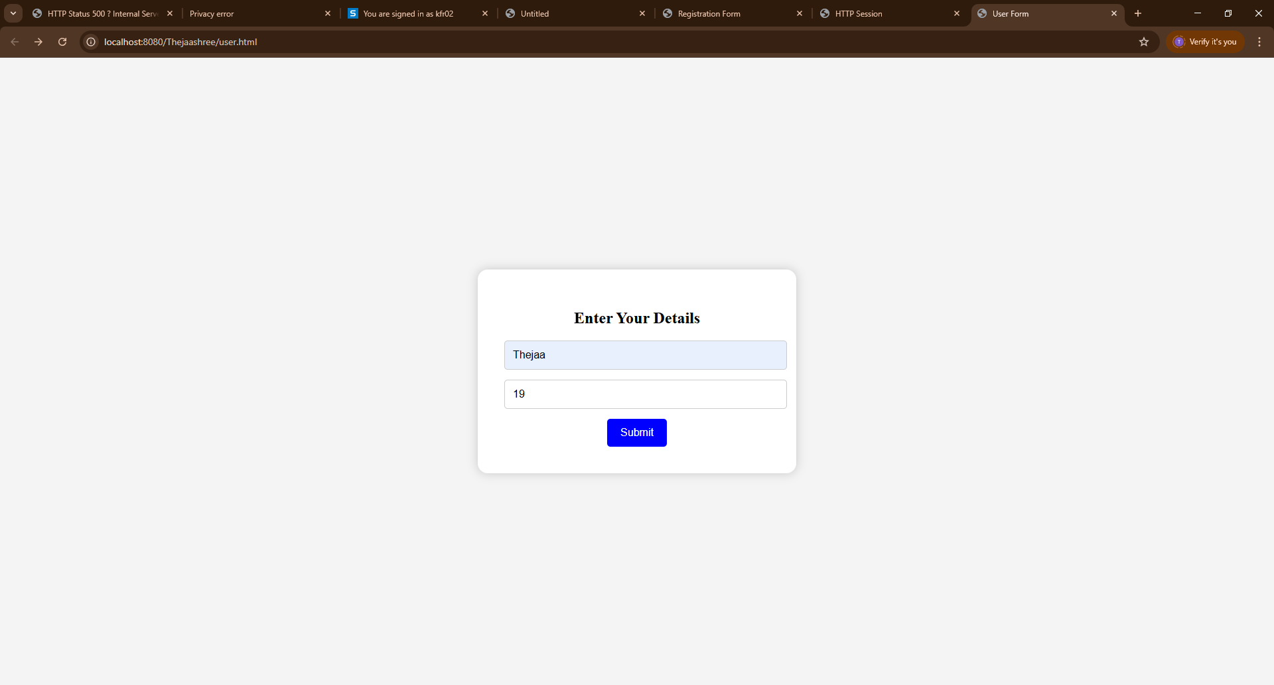

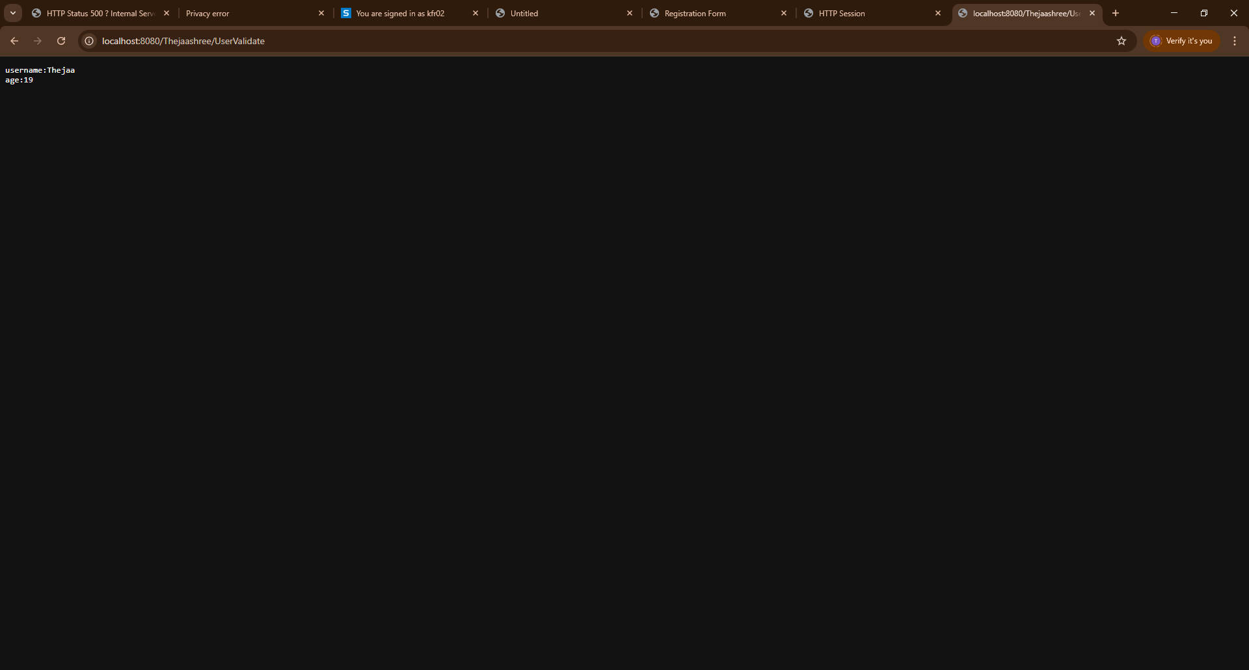

Result:
Thus the program was successfully executed.

